Noman Sadiq S/o Muhammad Sadiq
Mobile: +971 52 1920044
Email: nomi.cs786@gmail.com

LinkedIn : https://www.linkedin.com/in/nomancs/
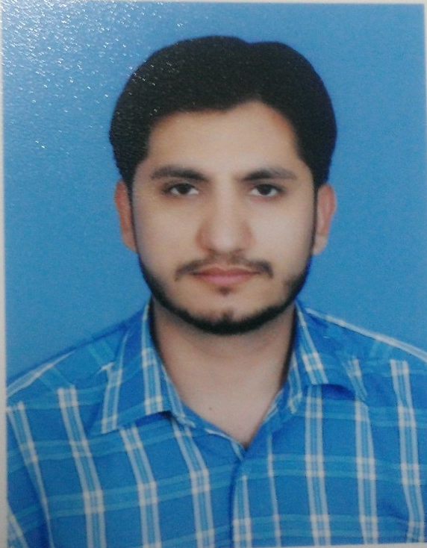

Objective
Looking for a prospect where technical competence is valued and where I can make meaningful contribution to the growth of the company and can be a part of the technical innovation, willing to work as a key player in challenging & creative environment. I am seeking a challenging area of work to apply existing skills and to continue the learning process.

Experiences
DevOps Engineer / Release Eng | Feb 2017 to Present
at OSN (Orbit Showtimes Network, Dubai, UAE)

Technical Responsibility

- Support for live Application deployment(s)
- Architecting, maintaining and streamlining our automated build and releases
- Managing source code branches and fixing the code conflict issues
- Have experience in Cloud (AWS, Azure and Google) environment deployment process
- Create and maintain the build and release document
- Support for quick resolution of problems found during the daily builds and deployments
- Work closely with development team to integrate deployment processes and strategies to meet our feature requirements
- Develop powershell script to automate the processes
- Support for business application(s) to improve the scalability and stability and efficiency with which we release our services
- Support for live issues (broadcast Application(s))
- Enhancement on existing Web and Desktop Applications
- Write complex queries SQL for log analysis on live deployments
- Design the dashboard on live application performance measuring

Technical Utilities

- VSTS, Jenkins, Ansible, Docker, Kubunaters, Newrelic
- HTML, CSS, JavaScript, Jquery
- ASP.NET (C#, VB)
- SQL, ORACLE, Entityframework
- Desktop and Console application
- JSON, XML
- SSIS
- REST and Soap services

Other Responsibility

- Design and Implementation Business Applications according to business domain
- Communicate with different departments for discuss the business requirements
- Representation of the application to the business users and stack holders
- Analyzing client existing systems and business domain
- Translating business user requirements into high specified project briefs
- Identifying options for potential solutions and assessing them for both technical and business suitability
- Working closely with colleagues, developers, testers and a variety of end users to ensure technical compatibility and user satisfaction
- Handling multiple projects
- Planning and working flexibly to deadlines
- Supporting users on change control and system updates
- Responsible for data integrity
- To ensure a top quality product that meets business needs
- Provided Daily, weekly, Monthly reports of Applications
- Responsible for quality of work
- Providing training and user manuals to users of a new system
- Prepares Technical Test Design Documentations
- Used Agile development approach

Computer Programmer / Analyst | March 2016 to Jan 2017
at Visual Sparks Technologies (Dubai, UAE)

Technical Responsibility

- Design Web application using bootstraps and front end technologies (HTML, CSS, JAVASCRIPT, JQUERY)
- Develop the Web Application in (ASP.NET MVC C#)
- Develop the web services (REST, SOAP) for mobile application
- Integration third party API services
- Develop the Web Application in third party tools
- Develop the web application in (Telerik Sitefinity ASP.NET C#)
- Write database schema for web application
- Design the database for the business applications (SQL Server)
- Write store procedure for business logic
- Write complex queries in Entity frameworks

Other Responsibility

- Design and Implementation Business Applications
- Communicate with clients to gather the requirements
- Representation of the application to the business users and stack holders
- Work with clients remotely and on site
- Analyzing client existing systems and business models
- Translating client requirements into high specified project briefs
- Identifying options for potential solutions and assessing them for both technical and business suitability
- Working closely with colleagues, developers, testers and a variety of end users to ensure technical compatibility and user satisfaction
- Handling multiple projects
- Planning and working flexibly to deadlines
- Supporting users on change control and system updates
- Responsible for data integrity
- To ensure a top quality product that meets client needs
- Provided weekly reports of Applications
- Responsible for quality of work
- Providing training and user manuals to users of a new system
- Prepares Technical Test Design Documentations
- Used Agile development approach

Senior Software Engineer | March 2015 to Feb 2016
at FutureNow Technologies (Lahore, Pakistan)

- Coordination with Project Manager and senior leads
- Manage the team
- Design and develop web application
- Design and develop web API
- Design and Implementation Database
- Handling multiple projects
- Responsible for deadlines
- Responsible for data integrity
- To ensure a top quality product that meets client needs
- Provided Daily Basis report
- Responsible for quality of work
- Prepares user manuals for application
- Technical Documentations
- Used Agile development approach
- Developed SSIS packages and SSRS reports
- API development

Programmer / Application Analyst | June 2014 to Feb 2015
at Mantic Sol, Lahore, Punjab, Pakistan

- Assist to manager / Chief Operating Officer
- Direct Communicate to Manger / CEO regarding about Application Analysis
- Leading to team
- Handling multiple projects
- Develop Application
- Design and implement database
- Responsible of client ad-hoc requirements
- Responsible of client deadline or met them these deadlines.
- Responsible for data integrity
- Analysis of remote server data
- Providing daily reporting each project

Software Engineer / Programmer | Jan 2013 to May 2014
at SELTS UK, (Lahore, Pakistan)

- Designing Database their development
- Data Analysis and Data management
- Development of Client/Server, web based and n-tier application.
- Worked extensively with Data Adapter, Dataset, Data reader as a part of ADO.NET to access and update database.
- Written Stored Procedures, triggers and Views using SQL in SQL Server 2008
- Worked in debugging an application using the debugging tools provided by the visual Studio IDE 12.
- Functional domain experience involves Education, Teaching/Testing System, Finical Management System
- Integrate the system with PayPal
- Database Level sessions
- Integrate Audio and Video tools with application (Sliver light or Flash)
- Integration WebRTC (Real Time Communication)
- System Control Panel
- System Authorities
- Deployment
- Effective in working independently and collaboratively in teams.

Junior .Net Developer | March 2012 to Dec 2012
at Soft Consults, Lahore, Punjab, Pakistan

- Experience in analysis, design and development of Client/Server, web based and n-tier application.
- Responsible for the development and support of the4 ERP systems
- Implement new features and intranet-based financial and operational reporting supporting 50 users
- Designed and implemented transactional and reporting database systems based on SQL Server (2005, 2008) and DTS Packages.
- Develop the Web base application using ASP.NET (C# SQL 2008) and Javascript and JQuery
- Responsible for the system administration and database administration for SQL Server databases for ERP System.
- Supported ad hoc reporting requests from financial and business executives.
- Documented the business rules used to roll up and report on all corporate financial requirements for the ERP Systems
- Worked extensively with Data Adapter, Dataset, Data reader as a part of ADO.NET to access and update database.
- Written Stored Procedures, triggers using SQL in SQL Server 2005 or 2008
- Worked in debugging an application using the debugging tools provided by the visual Studio IDE.
- Functional domain experience involves Financial, Telecom and University management system.
- Effective in working independently and collaboratively in teams.

Academics
BS Computer Science
at Virtual University, Lahore, Punjab, Pakistan
Major Subjects:

C++, OOP (Object Oriented Programming), Database Management System, Software Engineer, Java or Java Applet, Visual Programming, Assembly Language, Computer Graphics, Operating System, Data warehousing, Artificial Intelligent, System Programming

